


SPLITTING A DATASET INTO

MONTHLY SUBSET USING TIDYR

A PROJECT REPORT

Submitted by

NEHA HENIN J (2303811714822025)

in partial fulfillment of requirements for the award of the course

AGI1252-FUNDAMENTALS OF DATASCIENCE USING R

in

ARTIFICIAL INTELLIGENCE AND MACHINE LEARNING

K. RAMAKRISHNAN COLLEGE OF TECHNOLOGY
(An Autonomous Institution, affiliated to Anna University Chennai and Approved by AICTE, New Delhi)

SAMAYAPURAM – 621 112

JUNE 2025

i

K. RAMAKRISHNAN COLLEGE OF TECHNOLOGY

(AUTONOMOUS)

SAMAYAPURAM– 621 112 BONAFIDE CERTIFICATE
Certified that this project report on “SPLITTING A DATASET INTO MONTHLY SUBSET USING TIDYR” is the bonafide work of NEHA HENIN.J(2303811714822025) who carried out the project work during the academic year 2024 - 2025 under my supervision.
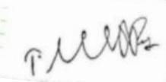
Signature

Signature
Mrs. SRI SANTHOSHINI M.E., Dr. T. AVUDAIAPPAN M.E.,Ph.D.,

SUPERVISOR, HEAD OF THE DEPARTMENT,

Department of Artificial Intelligence, Department of Artificial Intelligence
K. Ramakrishnan College of Technology , K. Ramakrishnan College of Technology , Samayapuram, Trichy -621 112. Samayapuram, Trichy -621 112.
Submitted for the viva-voce examination held on 02.06.2025




INTERNAL EXAMINER EXTERNAL EXAMINER

DEPARTMENT OF ARTIFICIAL INTELLIGENCE
VISION OF THE INSTITUTION
To serve the society by offering top-notch technical education on par with global standards.
MISSION OF THE INSTITUTION
- Be a centre of excellence for technical education in emerging technologies by exceeding the needs of industry and society.
- Be an institute with world class research facilities.
- Be an institute nurturing talent and enhancing competency of students to transform them as all- round personalities respecting moral and ethical values.
VISION AND MISSION OF THE DEPARTMENT

To excel in education, innovation and research in Artificial Intelligence and Machine Learning to fulfill industrial demands and societal expectations.
Mission 1: To educate future engineers with solid fundamentals, continually improving teaching methods using modern tools.
Mission 2: To collaborate with industry and offer top-notch facilities in a conductive learning environment.
Mission 3: To foster skilled engineers and ethical innovation in AI and ML for global recognition and impactful research.
Mission 4: To tackle the societal challenge of producing capable professionals by instilling employability skills and human values.
PROGRAM EDUCATIONAL OBJECTIVES (PEOS)

PEO 1: Compete on a global scale for a professional career in Artificial Intelligence and Machine Learning.
PEO 2: Provide industry-specific solutions for the society with effective communication and ethics.
PEO 3: Hone their professional skills through research and lifelong learning initiatives.

PROGRAM OUTCOMES :
Engineering students will be able to:
- Engineering knowledge: Apply the knowledge of mathematics, science, engineering fundamentals, and an engineering specialization to the solution of complex engineering problems.
- Problem analysis: Identify, formulate, review research literature, and analyze complex engineering problems reaching substantiated conclusions using first principles of mathematics, natural sciences, and engineering sciences.
- Design/development of solutions: Design solutions for complex engineering problems and design system components or processes that meet the specified needs with appropriate consideration for the public health and safety, and the cultural, societal, and environmental considerations.
- Conduct investigations of complex problems: Use research-based knowledge and research methods including design of experiments, analysis and interpretation of data, and synthesis of the information to provide valid conclusions.
- Modern tool usage: Create, select, and apply appropriate techniques, resources, and modern engineering and IT tools including prediction and modeling to complex engineering activities with an understanding of the limitations.
- The engineer and society: Apply reasoning informed by the contextual knowledge to assess societal, health, safety, legal and cultural issues and the consequent responsibilities relevant to the professional engineering practice.
- Environment and sustainability: Understand the impact of the professional engineering solutions in societal and environmental contexts, and demonstrate the knowledge of, and need for sustainable development.
- Ethics: Apply ethical principles and commit to professional ethics and responsibilities and norms of the engineering practice.
- Individual and team work: Function effectively as an individual, and as a member or leader in diverse teams, and in multidisciplinary settings.

- Communication: Communicate effectively on complex engineering activities with the engineering community and with society at large, such as, being able to comprehend and write effective reports and design documentation, make effective presentations, and give and receive clear instructions.
- Project management and finance: Demonstrate knowledge and understanding of the engineering and management principles and apply these to one’s own work, as a member and leader in a team, to manage projects and in multidisciplinary environments.
- Life-long learning: Recognize the need for, and have the preparation and ability to engage in independent and life-long learning in the broadest context of technological change.

PROGRAM SPECIFIC OUTCOMES (PSOs)
  - PSO 1: Capable of working on data-related methodologies and providing industry-focussed solutions.
  - PSO2: Capable of analysing and providing a solution to a given real-world problem by designing an effective program.

ABSTRACT

Time-series data is prevalent across domains such as finance, environmental science, public health, and business analytics. Analyzing such data often requires breaking it down into consistent time intervals — such as months — to enable pattern recognition, anomaly detection, and comparative analysis. This process can be streamlined using the R programming language, particularly with the tidyverse ecosystem, which includes the tidyr, dplyr, and lubridate packages.

This project presents a practical method for splitting a dataset into monthly subsets using tidyr, in combination with supporting packages. The workflow begins by ensuring that the dataset contains a valid date column, which is parsed and transformed into a standard Date format using lubridate. A new grouping variable is then created to represent each month, often using the floor_date() or format() function to capture the "year-month" structure (e.g., "2023-07"). This step ensures that the dataset can be grouped consistently across months regardless of day-level granularity.

Subsequently, the dataset is grouped by this "year-month" variable using dplyr::group_by(), and then split into a list of tibbles using dplyr::group_split(). This list structure allows for easy iteration or functional mapping, enabling operations such as plotting, statistical modeling, or exporting on a per-month basis. The approach provides a tidy and reproducible means of decomposing large datasets into meaningful temporal segments, making it especially valuable for longitudinal analysis or report automation.

TABLE OF CONTENTS
CHAPTER NO. | TITLE | PAGE NO.
 | ABSTRACT
1 | INTRODUCTION | 1
 | 1.1 Objective | 1
 | 1.2 Overview | 1
 | 1.3 R and Statistical Concepts | 2
2 | PROJECT METHODOLOGY | 8
 | 2.1 Proposed Work | 8
 | 2.2 Block Diagram | 8
3 | MODULE DESCRIPTION | 9
 | 3.1 File Upload & Input Handling | 9
 | 3.2 Data Cleaning & Preprocessing | 9
 | 3.3 Summary Statistics Calculation | 10
 | 3.4 Visualization & Reporting | 10
4 | CONCLUSION & FUTURE SCOPE | 11
5 | APPENDIX A SOURCE CODE | 12
 | APPENDIX B SCREENSHOTS | 16
 | REFERENCES | 19

CHAPTER 1
INTRODUCTION

1.1 Objective

The objective of this module is to preprocess and organize time-series data by dividing it into monthly subsets using tidy verse tools in R. This involves transforming the date column to extract consistent monthly identifiers, grouping the dataset by month, and splitting it into smaller, manageable tibbles. The goal is to enable efficient monthly-level analysis, reporting, or visualization by structuring the data into clean, time-based partitions that align with typical analytical or business reporting cycles.

1.2 Overview

The Time-series data is commonly used across fields such as finance, marketing, public health, and environmental monitoring. Analyzing this data effectively often requires breaking it down into fixed time intervals—most commonly months—to detect trends, seasonal patterns, and changes over time. This module presents a systematic approach to splitting a dataset into monthly subsets using the tidyverse ecosystem in R, specifically tidyr, dplyr, and lubridate.
The workflow begins by ensuring that the dataset includes a valid and properly formatted date column. Using lubridate, the date is transformed to extract a consistent "year-month" representation, which becomes the basis for grouping. dplyr functions like mutate(), group_by(), and group_split() are then used to organize and divide the data into a list of tibbles—each representing a unique month.
This modular structure allows for efficient and scalable operations such as month-wise reporting, plotting, forecasting, and exporting. Whether working with daily sales data, sensor logs, or public health records, this method simplifies temporal data handling and enhances the clarity and manageability of downstream analysis.

1.3 R Programming Concepts

- Data Types and Type Conversion:
Understanding and converting between different data types (e.g., character to Date, numeric to factor) is critical when working with time-based data.

- Vectorization:
R is a vectorized language, and operations on entire columns (vectors) — like extracting months or years — are more efficient than looping through rows.

- Functional Programming:
Using functions as first-class objects (e.g., with purrr::map()) allows for concise, scalable code that can apply operations to each element of a list.

- Immutable Data Structures:
In tidyverse workflows, data frames (tibbles) are typically not modified in place. Instead, new transformed versions are created — a concept from functional programming.

- Declarative Programming:
Tidyverse code expresses what should be done (e.g., "group by this column") rather than how to do it. This makes code more readable and less imperative.

- Lazy Evaluation:
Many tidyverse operations are evaluated only when needed (e.g., grouped operations aren’t computed until explicitly called with summarise() or group_split()).

- Scoping and Variable Binding:
Understanding how variables are scoped inside anonymous functions (e.g., within map()) is essential for avoiding name conflicts or errors.

- Data Abstraction:
Lists of tibbles represent higher-order data structures — abstractions that allow grouping and nested operations across subsets of data.
- String Manipulation:
Creating formatted time labels (e.g., "2023-05") often involves converting date objects to strings using format() or string interpolation.
- Control Flow (Optional):
While rarely needed in vectorized tidyverse code, understanding conditionals (if, case_when) and iteration (for loops, though map() is preferred) is foundational.
- Tidy Data Principles:
Ensuring the data follows a clean structure: one variable per column, one observation per row, and one table per observational unit. This concept guides the entire design.
- Data Transformation Pipelines:
The use of the pipe operator (%>%) allows chaining of multiple transformations in a readable, modular way — emphasizing composability.

  - Proposed Work

CHAPTER 2

PROJECTMETHODOLOGY

The proposed work involves developing a streamlined and reproducible workflow in R to split a time-series dataset into monthly subsets using the tidyverse packages, primarily tidyr, dplyr, and lubridate. The process begins with importing and cleaning the dataset, ensuring that the date column is properly parsed into a standard date format. Next, a new variable representing the year and month is created to facilitate grouping. The dataset is then grouped by this monthly identifier and split into separate tibbles using group_split(). Functional programming tools such as those from the purrr package may be applied to automate further analysis, visualization, or export of each monthly subset. This modular approach aims to enhance efficiency, scalability, and reproducibility, making it adaptable for various time-series data analysis tasks.
This approach not only simplifies the management of large and complex time-series datasets but also improves the clarity and focus of temporal analyses by isolating data into meaningful, consistent monthly segments. By leveraging tidyverse's intuitive syntax and functional programming paradigms, the workflow supports scalable data manipulation and facilitates integration with downstream processes such as reporting, forecasting, and visualization. Ultimately, this method empowers analysts and data scientists to extract actionable insights efficiently, while maintaining clean and reproducible code practices.

  - Block Diagram

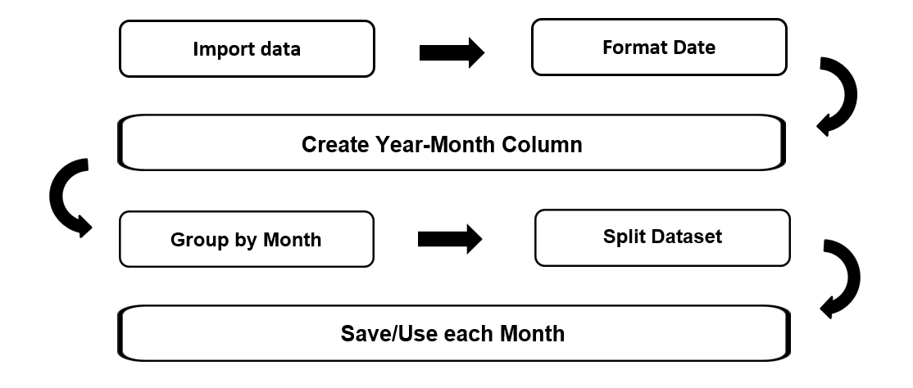
Fig 2.1 Block diagram
CHAPTER 3
MODULE DESCRIPTION

3.1 Module 1 : Data Import and Cleaning:
Handles all user input across the application,including validation and
preprocessing. Collects input from the user via the GUI. Validates input data (e.g., dates, room IDs, event details).Sends the processed data to relevant modules.

3.2 Module 2 : Date Transformation and Feature Engineering:
Create a consistent monthly identifier to group data by month.Extract year and month from date using lubridate::floor_date() or format().Add a new column (e.g., year_month) for grouping

3.3 Module 3 : Grouping and Splitting Data:
Organize data by month and split it into monthly subsets for focused analysis.Group data by year_month using dplyr::group_by().Split grouped data into a list of monthly tibbles using group_split()

3.4 Module 4 : Functional Processing of Monthly Subsets:
Automate further processing on each monthly subset.Use purrr::map() or loops to apply functions such as summarization, visualization, or export on each monthly tibble

This Splitting a dataset into monthly subsets using tidyr and dplyr is a powerful approach for organizing and analyzing time-series or date-based data. By first ensuring the presence of a properly formatted date column, and then using functions like mutate() to extract the year and month, we can group the data meaningfully by time intervals. The group_by() function allows us to define these monthly groups, and group_split() or nest() provides a convenient way to separate the data into individual tibbles for each month.
This method enhances both analytical flexibility and performance, especially when dealing with large datasets or performing operations that vary over time. It allows for:
- Isolated Analysis: Each monthly subset can be analyzed independently, making it easier to identify seasonal patterns, outliers, or monthly trends.
- Improved Readability: Organizing data by month reduces clutter and makes downstream tasks—like visualization or modeling—more structured.
- Modular Processing: Data engineers and analysts can apply different preprocessing steps or models to different months, if needed.
Overall, this workflow improves clarity, reproducibility, and scalability in time-based data workflows. It is a foundational technique in exploratory data analysis (EDA), forecasting, and reporting tasks

- Uploading file

CHAPTER 5 CONCLUSION

This Splitting a dataset into monthly subsets using tidyr and dplyr is a powerful approach for organizing and analyzing time-series or date-based data. By first ensuring the presence of a properly formatted date column, and then using functions like mutate() to extract the year and month, we can group the data meaningfully by time intervals. The group_by() function allows us to define these monthly groups, and group_split() or nest() provides a convenient way to separate the data into individual tibbles for each month.
This method enhances both analytical flexibility and performance, especially when dealing with large datasets or performing operations that vary over time. It allows for:
- Isolated Analysis: Each monthly subset can be analyzed independently, making it easier to identify seasonal patterns, outliers, or monthly trends.
- Improved Readability: Organizing data by month reduces clutter and makes downstream tasks—like visualization or modeling—more structured.
- Modular Processing: Data engineers and analysts can apply different preprocessing steps or models to different months, if needed.
Overall, this workflow improves clarity, reproducibility, and scalability in time-based data workflows. It is a foundational technique in exploratory data analysis (EDA), forecasting, and reporting tasks

CHAPTER 5 CONCLUSION

This Splitting a dataset into monthly subsets using tidyr and dplyr is a powerful approach for organizing and analyzing time-series or date-based data. By first ensuring the presence of a properly formatted date column, and then using functions like mutate() to extract the year and month, we can group the data meaningfully by time intervals. The group_by() function allows us to define these monthly groups, and group_split() or nest() provides a convenient way to separate the data into individual tibbles for each month.
This method enhances both analytical flexibility and performance, especially when dealing with large datasets or performing operations that vary over time. It allows for:
- Isolated Analysis: Each monthly subset can be analyzed independently, making it easier to identify seasonal patterns, outliers, or monthly trends.
- Improved Readability: Organizing data by month reduces clutter and makes downstream tasks—like visualization or modeling—more structured.
- Modular Processing: Data engineers and analysts can apply different preprocessing steps or models to different months, if needed.
Overall, this workflow improves clarity, reproducibility, and scalability in time-based data workflows. It is a foundational technique in exploratory data analysis (EDA), forecasting, and reporting tasks

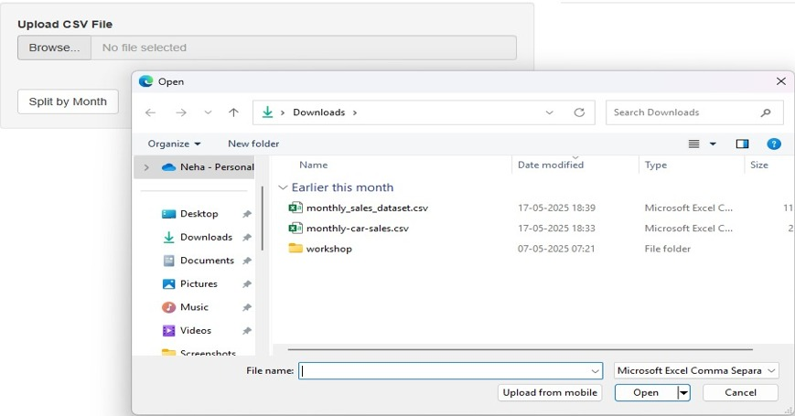

Fig 4.1 Uploading file

CHAPTER 4 RESULTS AND DISCUSSION

2 .File Uploaded

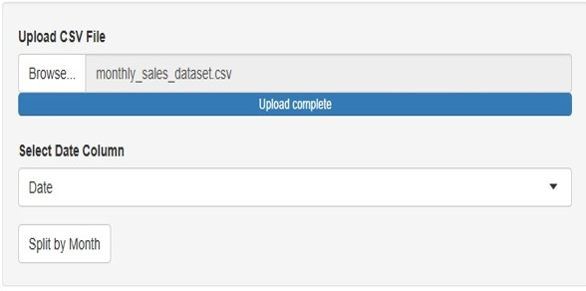
Fig 4.2 File Uploaded
3. Select date column
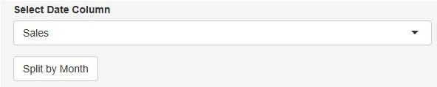

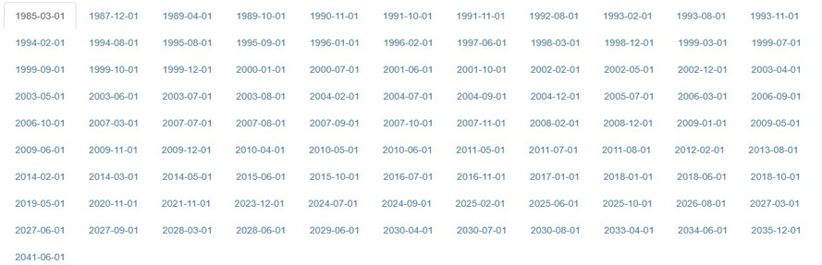
Fig 4.3 Select date column
4.Date splitted

Fig 4.4 Date splitted

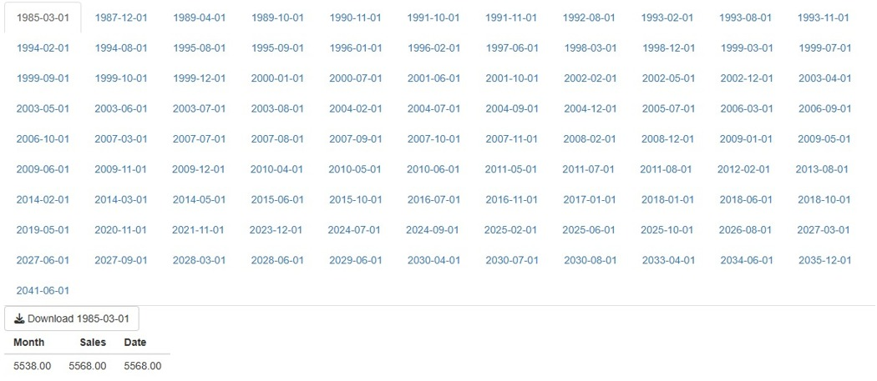
Fig 4.5 Data splitted according to month
5. Data splitted according to month

CHAPTER 5 CONCLUSION

This Splitting a dataset into monthly subsets using tidyr and dplyr is a powerful approach for organizing and analyzing time-series or date-based data. By first ensuring the presence of a properly formatted date column, and then using functions like mutate() to extract the year and month, we can group the data meaningfully by time intervals. The group_by() function allows us to define these monthly groups, and group_split() or nest() provides a convenient way to separate the data into individual tibbles for each month.
This method enhances both analytical flexibility and performance, especially when dealing with large datasets or performing operations that vary over time. It allows for:
- Isolated Analysis: Each monthly subset can be analyzed independently, making it easier to identify seasonal patterns, outliers, or monthly trends.
- Improved Readability: Organizing data by month reduces clutter and makes downstream tasks—like visualization or modeling—more structured.
- Modular Processing: Data engineers and analysts can apply different preprocessing steps or models to different months, if needed.
Overall, this workflow improves clarity, reproducibility, and scalability in time-based data workflows. It is a foundational technique in exploratory data analysis (EDA), forecasting, and reporting tasks

REFERENCES:

- Wickham, H., François, R., Henry, L., & Müller, K. (2023). dplyr: A Grammar of Data Manipulation. R package version 1.1.4. Available at: https://CRAN.R-project.org/package=dplyr

- Wickham, H. (2023). tidyr: Tidy Messy Data. R package version 1.3.0. Available at: https://CRAN.R-project.org/package=tidyr

- Wickham, H. et al. (2019). Welcome to the tidyverse. Journal of Open Source Software, 4(43), 1686. DOI: 10.21105/joss.01686

- R Core Team (2024). R: A language and environment for statistical computing. R Foundation for Statistical Computing, Vienna, Austria. Available at: https://www.R-project.org/

APPENDIX
(Source Code)

library(shiny)
library(tidyverse)
library(lubridate)

ui <- fluidPage(
titlePanel("Monthly Dataset Splitter"),

sidebarLayout(
sidebarPanel(
fileInput("file", "Upload CSV File", accept = ".csv"),
uiOutput("date_col_ui"),
actionButton("split_btn", "Split by Month")
),

mainPanel(
uiOutput("month_tabs")
)
)
)

server <- function(input, output, session) {
dataset <- reactiveVal(NULL)
split_data <- reactiveVal(list())

observeEvent(input$file, {
req(input$file)
df <- read_csv(input$file$datapath, show_col_types = FALSE)
dataset(df)
})

output$date_col_ui <- renderUI({
req(dataset())
selectInput("date_col", "Select Date Column", choices = names(dataset()))
})

observeEvent(input$split_btn, {
req(dataset(), input$date_col)
df <- dataset()
# Convert to Date
df <- df %>%
mutate(Date = as.Date(.data[[input$date_col]])) %>%
filter(!is.na(Date)) %>%
mutate(Month = floor_date(Date, unit = "month"))

# Split into list by Month
split_list <- split(df, df$Month)
split_data(split_list)
})

output$month_tabs <- renderUI({
req(split_data())
tabs <- lapply(names(split_data()), function(month) {
df <- split_data()[[month]]
tabPanel(
month,
downloadButton(paste0("download_", month), paste("Download ", month)),
tableOutput(paste0("table_", month))
)
})
do.call(tabsetPanel, tabs)
})

observe({
req(split_data())
lapply(names(split_data()), function(month) {
local({
m <- month
df <- split_data()[[m]]
output[[paste0("table_", m)]] <- renderTable({
head(df, 10)
})

output[[paste0("download_", m)]] <- downloadHandler(
filename = function() paste0("data_", m, ".csv"),
content = function(file) {
write_csv(df, file)
}
)
})
})
})
}

shinyApp(ui, server)

